DISASTER DAMAGE ASSESSMENT USING
SEMANTIC CHANGE DETECTION AND DEEP
LEARNING: AN AUTOMATED FRAMEWORK FOR
DAMAGE CLASSIFICATION
Author: G. Karthika (23NG1A6118), M. Vijaya (23NG1A6139)
Y. Ajay(23NG1A6164), V. Praveen (23NG1A6159)
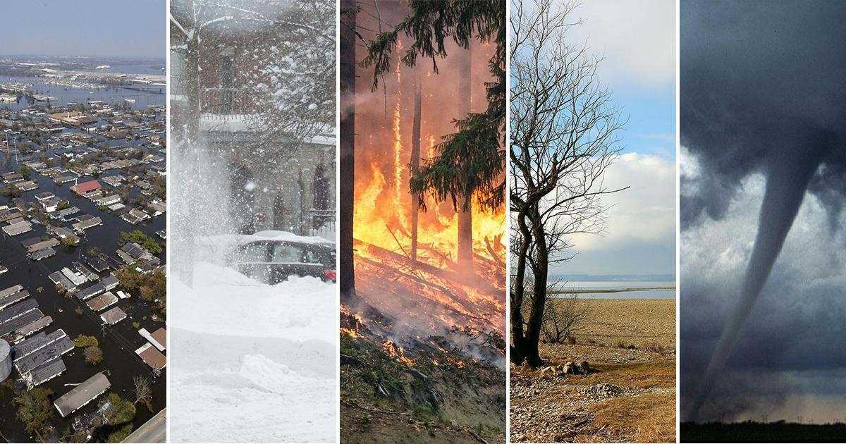

ABSTRACT
- Accurate and timely damage assessment is crucial for effective disaster response and resource allocation.
- The project introduces an automated framework using Siamese Neural Networks and YOLOv8 instance segmentation.
- Before-and-after satellite/drone imagery is analyzed for structural changes.
- Integrated change detection + object recognition enables precise identification of building footprints.
- Damage severity is quantified using pixel-level change percentage.
- The system generates GIS-compatible damage classification reports.
- Provides emergency teams with timely, actionable insights for informed decision-making and response planning.

INTRODUCTION
- Rapid and accurate damage assessment is essential for effective emergency response and resource allocation.
- Traditional methods (manual surveys, 2D image interpretation) are slow, subjective, and often inconsistent.
- Deep learning enables automated, pixel-level damage detection using semantic change detection and segmentation.
- Siamese U-Net detects pixel-level structural changes, while YOLOv8 provides precise building footprints.
- The proposed framework integrates both models to classify structures as Minor, Major, or Destroyed.
- Generates GIS-compatible reports, reducing assessment time from weeks to minutes and improving response planning.

IMPLEMENTATION
Overall system architecture :
- The framework is a unified multi-stage pipeline for automated disaster damage assessment.
- Processes satellite and drone imagery using deep learning models.
- Workflow includes: data collection → preprocessing → semantic change detection → object segmentation → GIS-compatible classification.
- Each module works collaboratively to ensure smooth end-to-end analysis.
- Supports multiple disaster types: earthquakes, floods, cyclones, building collapses, etc.
- Ensure rapid, scalable, and accurate damage assessment.
- Designed for real-world emergency response and decision-making.

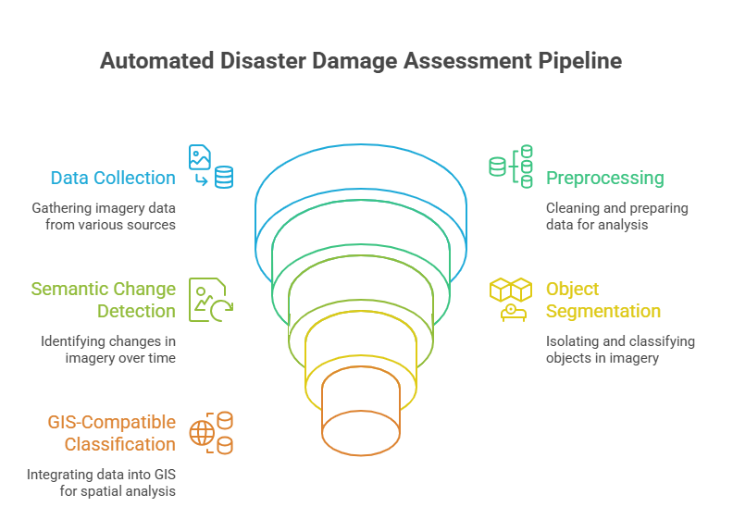

1. Data Sources and Acquisition
- Satellite data: Copernicus EMS, Sentinel-2, Planet Labs (10 m–submeter).
- Automated pre/post-disaster image retrieval.
- Drone data: DJI Phantom 4 RTK with high-overlap flights.
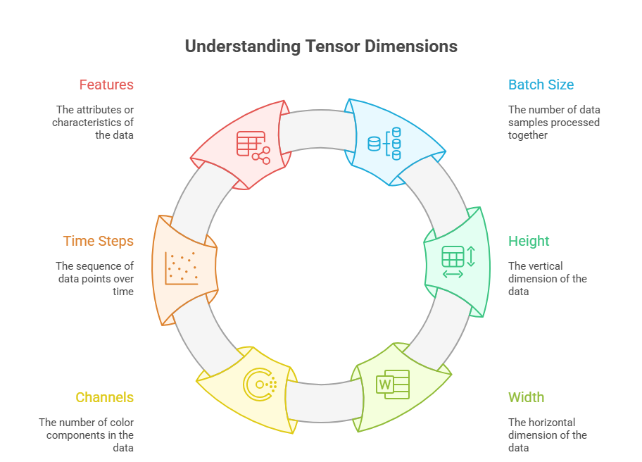
- Benchmark datasets: xBD, xView2, Copernicus EMS.
2. Preprocessing Workflow
Before feeding the images into the models, the system performs standard preprocessing operations:
- Resizing image pairs to a fixed resolution (512×512).
- Normalizing pixel values using mean and standard deviation vectors.
- Aligning pre- and post-disaster images to ensure spatial consistency. This preprocessing ensures that the Siamese U-Net receives properly formatted tensors for change detection. .
4. Deep Learning Model Training
- Modified U-Net with ResNet-50 encoder; input is stacked pre/post RGB (512×512×6).
- Losses: weighted cross-entropy + Dice; optimizer: Adam with LR scheduler.
- Augmentations: rotation, scaling, brightness shifts, cutout masks.
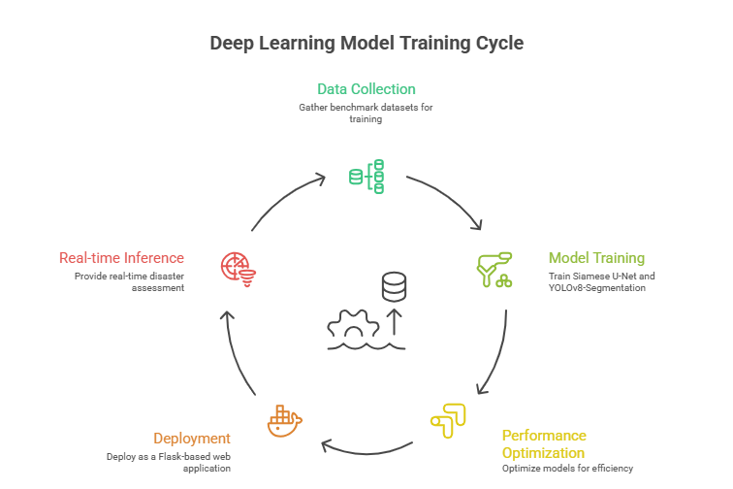
- Trained for up to 100 epochs on NVIDIA V100 with early stopping.
- Uses transfer learning from ImageNet + xView2, multi-scale inputs, cyclical learning rates.
Damage Severity Classification :
The system calculates damage severity using the Intersection over Area (IoA) method:
- Changed pixels (from Siamese U-Net) are intersected with building masks (from YOLOv8).
- The ratio of changed pixels to total building pixels gives the damage percentage.
- Classification thresholds: o Destroyed: > 70% o Major: 25–70% o Minor: 5–25% o Safe: ≤ 5%
This classification is displayed visually with color-coded bounding boxes
(Green = Safe, Orange = Major, Red = Destroyed) and summarized in a GIS-compatible report panel.
Tools and Technologies Used :

- Python 3.8
- PyTorch for Siamese U-Net training and inference
- Ultralytics YOLOv8 for building segmentation
- OpenCV, NumPy for image preprocessing and visualization
- Flask for web deployment and interactive analysis
- GDAL, Rasterio, GeoPandas for GIS compatibility and spatial data handling

RESULT
- The system performs post-disaster semantic change detection and building-level damage classification.
- Siamese U-Net identifies change regions between pre- and post-disaster images.
- YOLOv8 Segmentation extracts building footprints for object-level analysis.
- Damage is classified into four severity levels:
- Destroyed
- Major
- Minor • Safe
- Final output includes a GIS-compatible visual assessment with:
- Red change-detection overlays showing affected areas
- Color-coded bounding boxes around buildings
- Damage labels for each structure
- Summary panel showing total buildings + count per damage category
- The categorical output enables fast interpretation, aiding time-critical disaster response teams.

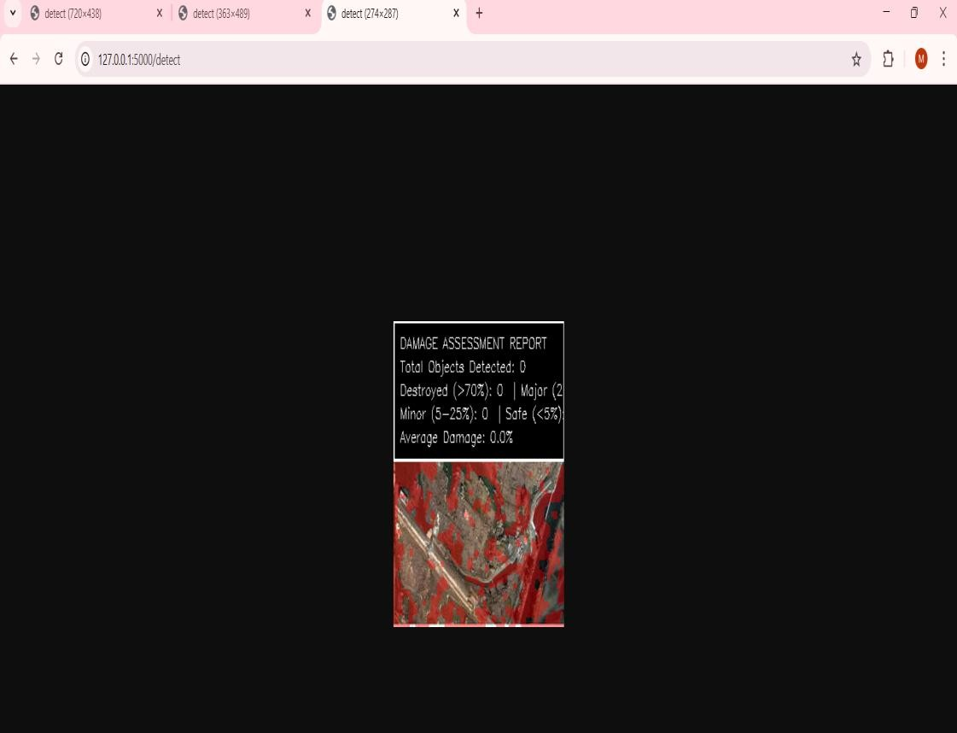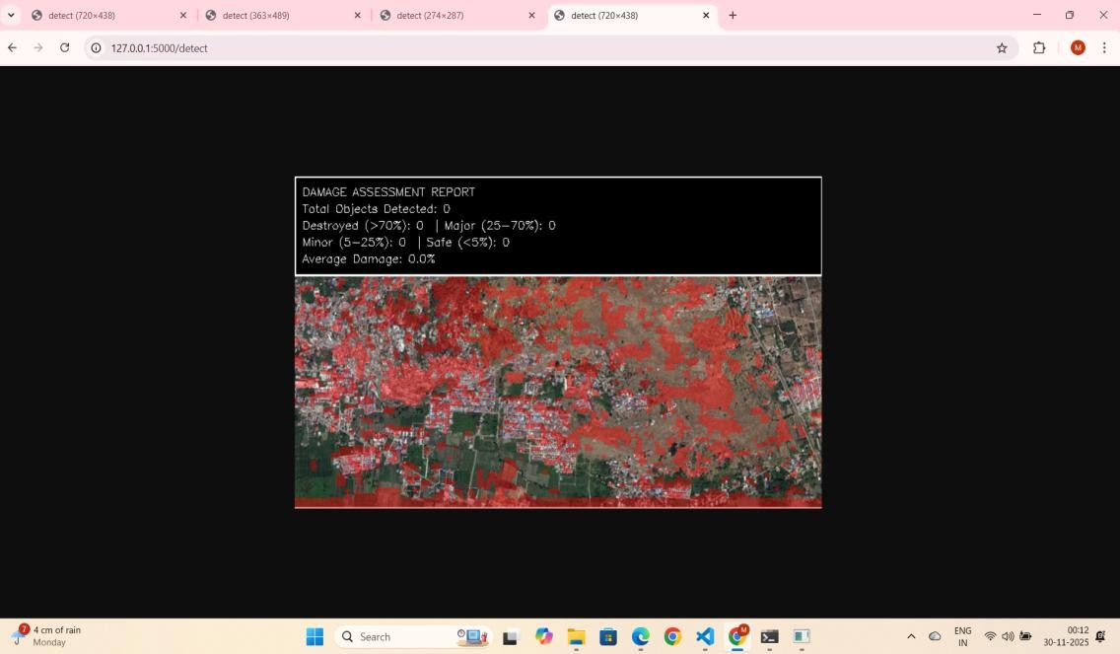
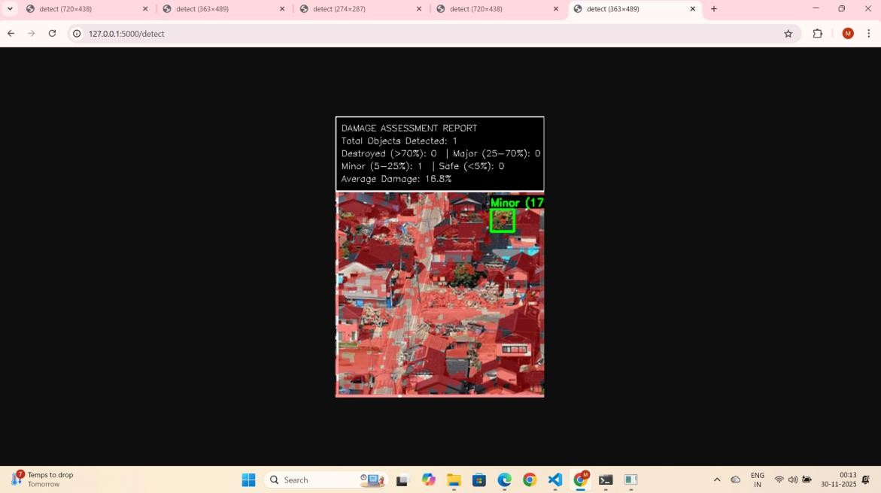

CONCLUSION
- The original plan included detailed damage percentage visuals and 3D debris estimation.
- The final system focuses solely on categorical damage levels (Destroyed, Major, Minor, Safe).
- This simplification improves clarity and speeds up decision-making for emergency responders.
- The system still calculates exact damage percentages internally using the IoA method. • These percentages appear in the summary statistics to maintain quantitative accuracy.
- Excluding volumetric/3D analysis makes the workflow faster, more stable, and practical.
- The final output remains fully GIS-compatible, linking each building’s location, category, and percentage.

FUTURE SCOPE
- Integrate damage-percentage values directly into bounding-box labels.
- Adopt transformer-based models (SegFormer, Swin-UNet) for improved segmentation.
- Use geospatial foundation models like Prithvi and SatMAE for better cross-region generalization.
- Incorporate SAR datasets (Sentinel-1) for reliable assessment during cloud, smoke, or nighttime.
- Explore LiDAR or lightweight 3D reconstruction for volumetric debris estimation.
- Enable edge deployment on devices like NVIDIA Jetson for real-time field analysis.
- Build automated GIS reporting pipelines and link outputs with hazard–vulnerability models for predictive insights.

